1 | Yes No Heavy lifting (greater than 35#)  Yes No Frequent  Yes No > 2 hours per day
Task(s):

Recommendations:

2 | Yes No Work below knee height (<15-20”)  Yes No Frequent  Yes No > 2 hours per day
Task(s):

Recommendations:

3 | Yes No Work above shoulder heights (>60”)  Yes No Frequent  Yes No > 2 hours per day
Task(s):

Recommendations:

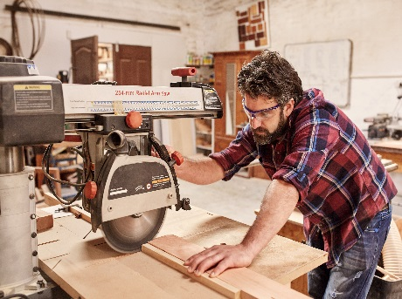
4 | Yes No Static forward bending (work too low)  Yes No Frequent  Yes No > 2 hours per day
Task(s):

Recommendations:

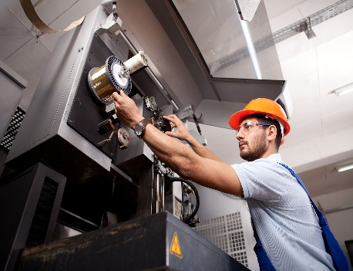
5 | Yes No Work at arm’s length (extended reaches)  Yes No Frequent  Yes No > 2 hours per day
Task(s):

Recommendations:

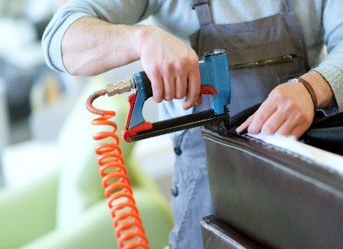
6 | Yes No Bent wrist and/or pinching  Yes No Frequent  Yes No > 2 hours per day
Task(s):

Recommendations:

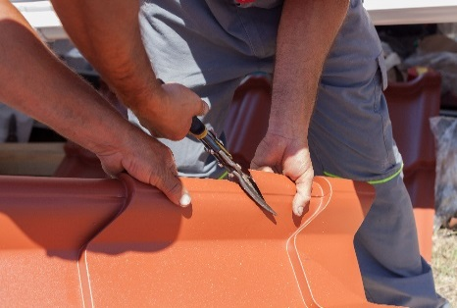
7 | Yes No Heavy grip and pinch force with hands and fingers  Yes No Frequent  Yes No > 2 hours per day
Task(s):

Recommendations:

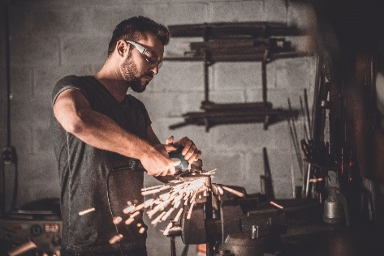
8 | Yes No Winging of the arms  Yes No Frequent  Yes No > 2 hours per day
Task(s):

Recommendations:

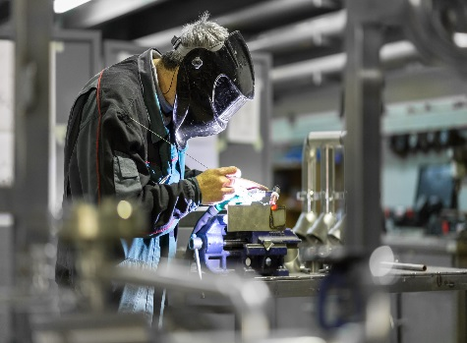
9 | Yes No Static forward head posture  Yes No Frequent  Yes No > 2 hours per day
Task(s):

Recommendations:

10 | Yes No Kneeling and prolonged standing  Yes No Frequent  Yes No > 2 hours per day
Task(s):

Recommendations:

