Load Securement Guidance & Resources
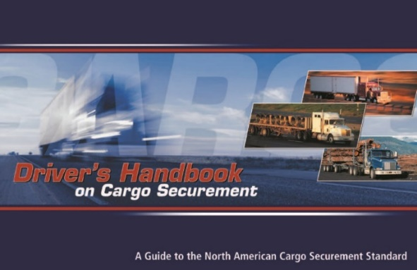
Federal Motor Carrier Safety Administration
Email: FMCSADeclaration@dot.gov
Phone: 877-831-2250
https://www.fmcsa.dot.gov/regulations/cargo-securement/drivers-handbook-cargo-securement

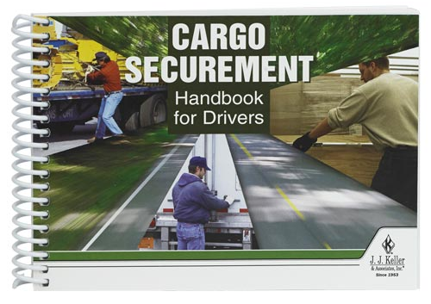
J.J. Keller & Associates, Inc.
Phone: 877-564-2333
https://www.jjkeller.com/shop/Product/Cargo-Securement-Handbook-for-Drivers?PromoCode=210137&gclid=CjwKCAjw3pWDBhB3EiwAV1c5rCOZ9RN30C5FhObutj4yWouInKWyXy3qQkuVWTC7QWCvAI5YuK8RDRoCJyEQAvD_BwE

Securement Hardware
Kinedyne https://www.kinedyne.com/
Ancra Cargo https://www.ancracargo.com/heavy-duty/c/2

Maine Commercial Vehicle Laws & Regulations
https://www.maine.gov/sos/bmv/commercial/Commercial%20Vehicle%20Laws%20&%20Regulations%20(June%206,%202012).pdf

Federal Securement Regulations (49 CFR)
https://www.maine.gov/sos/bmv/commercial/Commercial%20Vehicle%20Laws%20&%20Regulations%20(June%206,%202012).pdf

Maine Motor Transport Association
https://www.MMTA.com

Truckined
www.truckined.wordpress.com

Additional Resources
Minimum Tiedowns (PDF Handout)

